E Asset Tracking Report

The following report comprises of a preliminary market research that was performed with regards to the tracking systems used for personnel and/or work assets followed by a requirement-based analysis of the product(s). It provides an insight into the current market to help us find potential areas for innovation and the possibility of building a prototype using current tracking systems for implementation in an oil rig environment.

*Submitted by:*

*Alisha, Dillon, Franklin, Jordan, Rob and Woojin*

Table of Contents

2 Abstract 2

3 Introduction 3

3.1 Report Overview 3

3.2 Project Context 3

4 3. Sensor Networks 6

4.1 Summary table 6

4.2 Accurate Source Localisation 8

4.3 Design Issues 8

4.4 Power Constraints 9

4.5 Wireless Bandwidth 9

4.6 3.4 Network Latency 10

6 Requirements 11

6.1 System Requirements 11

6.1.1 Personnel Tracking 11

6.1.2 Equipment Tracking 11

6.1.3 Asset Location Analysis 11

6.1.4 Emergency Notification 11

6.1.5 Fatigue Monitoring 11

6.1.6 Seawater Detection 11

7 House Of Quality 12

8 Competitor Analysis 13

8.1 Competitor Technological Capability Summary 14

8.2 The Competitors 15

8.2.1 Progility Solutions 15

8.2.2 TracerTrak [11] 16

8.2.3 Identec Solutions [14] 18

8.2.4 Iottag [26] 19

8.2.5 ReadyTrack [27] 20

9 Scope for Innovation 23

10 Conclusion 24

11 References 25

12 Appendix 29

12.1 House of Quality 29

12.2 Pairwise Analysis 30

# Abstract

This paper aims to provide context into the importance of personnel safety in an oil rig environment followed by a preliminary market research into the development of a personnel/asset tracking system. The key requirements of the system include:

* Tracking asset and personnel locations,
* assisting with evacuation or rescue protocols, and
* monitoring worker fatigue levels.

Market research has found that the personnel/asset tracking market sector is a highly saturated one. However, a requirements-based approach, followed by the comparison of various commercial off-the-shelf (COTS) systems, suggests that there are areas in which existing systems could be improved to satisfy the clients requirements better and ensure that the system is well-suited to an oil rig environment.

# Introduction

## Report Overview

The following report discusses the need of a tracking device for managing personnel and assets present in an offshore oil rig. The report gives context to the problem and highlights reasons behind the prevalent existence of the issues present in such an environment, followed by an explanation of how the implementation of a tracking system can help with the resolution of such issues. The report conducts a requirements-based analysis to establish the main client requirements from the system, provides insight into sensor networks, analyses the current market and compares existing commercial off-the-shelf (COTS) systems. Prospective scopes for various innovation opportunities in relation with tracking systems are also built upon to better suit client needs.

## Project Context

There has been a particularly obvious trend in the use of technology to improve work conditions within the mining and offshore oil rig industries [4]. One such example is a system that tracks and manages on-site assets, such as personnel and equipment. Such a system could be beneficial for employers since it allows managers to quickly identify the location and status of everyone on site, monitor the usage of key equipment’s, and alert workers about emergencies. Implementing this system into a mine presents a variety of challenges, such as unknown and/or complicated layouts, poor network reception underground, hazards such as pockets of gas, etc. In comparison, oil rigs present a more rigid environment with commonly known hazardous events such as oil and gas leaks, workers falling into the ocean, and worker fatigue due to long shifts. As a result, the following report focuses on exploring the possibilities of developing a tracking system that can be used in an offshore oil-rig environment.

The complexity of site, coupled with personnel working at heights and in numerous confined spaces makes on-site safety a major issue for offshore oil-rigs [1]. Offshore oil rigs serve immense amounts of risks to the people and assets present in the worksite, primarily due to the high-risk activities that tend to take place in such a workplace on a regular basis. These activities involve a range of accidental risks such as falling objects, leaks, explosions, etc. [6]. Oil and gas drilling accounts for the highest critical injury incident rate in the petroleum industry [5]. Factors such as weather and low reliability rates of safety barriers significantly also add to the substantial amounts of risk that workers and loose equipment are faced with.

Table 1: risk matrix summarising the risks that could occur in an offshore oil rig

|  |  |  |  |
| --- | --- | --- | --- |
| **Risk** | **Likelihood** | **Impact** | **Risk Rating** |
| Oil and/or gas leaks | Possible | Catastrophic | CATASTROPHIC |
| Worker fatigue | Almost Certain | Moderate | HIGH |
| Worker fails to follow rules and regulations | Possible | Catastrophic | HIGH |
| Working at height | Almost Certain | Major | CATASTROPHIC |
| Heavy machinery and largely physical work | Almost Certain | Catastrophic | CATASTROPHIC |
| Bad weather | Almost Certain | Insignificant | MODERATE |
| Unreliable safety barriers | Possible | Catastrophic | HIGH |

Since the worksite is an oil rig platform in an offshore environment, the chances of recovering assets that have fallen into the sea can be very low and costly to replace. Workers failing to follow rules and regulations, together with emotional exhaustion and general fatigue, are also contributing factors to majority of serious incidents [6]. Offshore oil rig workers tend to be exposed to various physical stressors such as cramped physical environments, long work shifts, working in an isolated location, high noise levels, vessel motion, heavy physical work, lack of privacy, etc [7]. With such challenging work environmental conditions, it would undoubtedly be physically and mentally difficult for workers to consistently focus and be aware of their surroundings. Thereby, personnel safety is of essence in such an environment, especially since personnel interact with heavy machinery and hazardous materials daily.

The need to be able to effectively track and manage personnel and assets on-site is of utmost importance to ensure the safety of both. Given the dangerous line of work, if an emergency does occur, it is essential for oil rig companies to be able to manage personnel and evacuate or rescue them in the smallest possible timeframe. The implementation of a tracking system will enable the existence of a centralised unit to alert personnel of any emergency situations, determining the most efficient evacuation route and track the whereabouts of all personnel at any given time, to ensure that all workers are safe. The tracking of assets also ensures safety of the machinery used, their whereabouts, efficient locations to minimise time wastage etc. Injuries and loss of machinery can cost companies a lot of money. Hence, it is necessary to control the situation as soon as possible since “when errors are made in these workplaces, the consequences can be devastating” [6].

The conventional methods of assessing the safety of the workplace, such as fatigue levels, injuries and illness rates, are not adequate for use in an oil rig environment, considering the huge repercussions that a lapse in safety could cause [2]. An emergency can be very fatal for those on-site, and without the help of a streamlined system, it could lead to serious injuries or even fatalities. Considering the challenging environment, it is easy to lose track of personnel and assets, hence making it more essential that a tracking and monitoring system is in place. One major area of deficiency in current systems is the level of time efficiency evaluation it can perform; critically monitoring and evaluating personnel and asset movement can improve the efficiency on-site and make lives easier for the workers, giving they are already in a mentally and physically taxing line of work [3].

# 3. Sensor Networks

With a tracking system likely to involve the use of a Wireless Sensor Network (WSN) this section will aim to outline some of the key concepts and considerations when implementing these networks.

A WSN can be defined as am wireless network consisting of spatially distributed autonomous devices using sensors to monitor physical or environmental conditions. [15] The key concept of WSNs is to have sensor nodes scattered in an environment. These sensors could be of various types such as audio sensors, microphones, RF antennas and thermometers. The key challenges in using these networks are:

* Accurate Source Localisation
* Design Issues
* Power Constraints
* Wireless Bandwidth Constraints
* Network Latency

## Summary table

Table 2: summary of WSN challenges and mitigation techniques to avoid these

|  |  |  |
| --- | --- | --- |
| **Challenge** | **Issues** | **Mitigation Technique** |
| **Accurate Source Localisation** | Performance: more accurate systems require more performance. | Ensure that the required accuracy, real-time processing speed and coverage area are accounted for, with extra room, in the hardware considerations. |
| Cost and complexity: infrastructure cost of WSNs. | The infrastructure cost can be reduced by using umbrella localisation systems. |
| Security: location data must be secure | Develop secure protocols to prevent interference from unwanted sources. |
| **Design Issues** | Durability: sensor durability in harsh environments | Ensure the implemented system has the necessary precautions to ensure survival in an oil rig environment. |
| Fading and high error rate | Fading can be overcome by switching of node location or switching communication carrier frequency. [22]  Error rate control codes best suited for WSNs are binary-BCHs with ASIC implementation. [23] |
| Coverage Area: coverage loss caused by failure of sensor node | A distributed algorithm which identifies another node or nodes that contain the same capabilities of the failed node. [24] |
| Power Constraints | Limitations in processor bandwidth and memory | Fabrication techniques like LEACH protocol to save energy consumption and improve performance. |
| Wireless Bandwidth | Small processing power in each sensor node when using decentralised | Compute data centrally, which gives more accurate algorithms, but at cost of network latency. |

## Accurate Source Localisation

Source localisation is significantly relevant to the context of this problem since being able to identify the location of personnel and assets based on the detection method used is key to developing an effective tracking method. Estimating the source locations within a region covered by a WSN can be very challenging. [16] This is estimated using various kinds of sensors, ranging from acoustic to infrared sensors. Issues with accurate source localisation, with mobility, are [18]:

1. Performance: The localisation accuracy, the delay time to estimate location, the capacity (No. of requests to be processed) and coverage. The more accurate the system is that estimating the location of a node, the higher the performance requirements that the system needs to ensure that can cope with the information being processed.
2. Cost and complexity: on top of this, the cost of infrastructure for deploying the sensors and concerning the infrastructure need for more bandwidth just for the localisation process. The infrastructure cost can be reduced by using umbrella localisation system to cover a larger area. [19] [20]
3. Security: as privacy is great concern, the privacy of location information must be ensured to keep it away from being tracked. That's a very difficult matter when securing such signals. Depending on the situation, it may be simpler to develop secure protocols to prevent interference from unknown sources.

## Design Issues

There are many design issues that are related to WSNs that need to be kept in mind when designing a new system or evaluating existing systems [21]:

1. As the sensor nodes are deployed in an uncontrollable or harsh environment, it may be good to keep in mind the durability of the sensors themselves, as it may not be uncommon for the reliability of the nodes to degrade and or become faulty.
2. Whether the system is scalable is dependent on whether adding hardware improves the performance of the system itself, proportional to the capacity of the hardware that is added.
3. In a WSN, the nodes are wirelessly linked and hence, are subject to the traditional problems that affect WSNs: fading, high error rate etc. These will inversely affect the operation of the sensor network. [21] Shifting the location of one node or switching the communication carrier frequency can help to mitigate the effects of fading. [22] Due to the stringent energy constraint in sensor networks, energy efficient error control schemes are essential. Based on the study and comparison of the three different error control codes, Balakrishnan et. all [23] identified that binary-BCH codes with ASIC implementation are best suitable for wireless sensor networks.
4. The quality of the sensor network system itself is dependent on how well the system covers the area, or the coverage area of the network system. Hence, it is important to ensure that the implemented design takes this into consideration to ensure maximum coverage area with the implemented hardware. A distributed algorithm for mitigating the coverage loss caused by the failure of a sensor node can be used to mitigate coverage loss. The algorithm proposed by Kasinathan et. al [24] looks for *“one or multiple nodes that can be repositioned to fill the coverage gap. A search is conducted within the 2-hop neighbourhood to identify a node or a combination of multiple nodes that collectively possess the capabilities of the failed node. To maximize the performance of the network, the repositioned nodes are chosen such that there is a minimum coverage and connectivity impact on the network after the recovery.”*

## Power Constraints

The motivation behind the reduced computational complexity stems from the inherent hardware constraints. Often the nodes are powered by battery which leads to limited transmit power. These sensors can often feature a small amount of processing power in the form of a microprocessor, however these are not conductive to large amounts of data handling. Two of the big constraints in sensor networks are the limitations in processor bandwidth and memory, which could be solved with the development of fabrication techniques. Pooja et. al discuss critical limitations of WSNs like power and lifespan, communication bandwidth, memory size. They use the Low Energy Adaptive Clustering Hierarchy (LEACH) to decrease the energy overhead of the sensor nodes. *“The new approach is proposed entitled PV-LEACH which will save the energy consumption in cluster setup phase and in data transmission phase of the conventional LEACH protocol. So, this will enhance the performance ratio in terms of energy consumption and lifetime of the sensor nodes.”* [25]

## Wireless Bandwidth

A key design consideration is whether to process the data in a centralised or decentralised fashion. By using the small amount of processing power in each sensor the network can locate sources using a decentralised algorithm. The opposite approach is to compute the data centrally which can lead to more accurate algorithms at the cost of network latency.

## Network Latency

For the context of the problem, it is important that the information collected from the tracking device is transferred to the relevant parties in a timely manner to assist with various safety aspects such as emergency actions being taken as soon as an employee is seen to be in trouble, for example.

# 

# Requirements

## System Requirements

Based on the project brief, the key requirements for the tracking device are outlined below. These requirements are high level and can be broken down further into sub requirements. This will be done as part of the design process once the market analysis has been complete. For the purpose of the market analysis, the following requirements will be considered:

### Personnel Tracking

The system should be able to track and monitor the location of personnel, with the location being accessible in real time by relevant site supervisors for safety purposes.

### Equipment Tracking

The system should also be attachable to larger pieces of equipment and should be able to track the location of these assets, leading to improved efficiency and management of an oil rig.

### Asset Location Analysis

The system shall provide analysis tools for the data collected by the system. For example, the system should be able to provide information on patterns detected for activities such as:

* Worker movement
* Equipment Movement
* Safety Hazards

This information could then be used to improve efficiency and safety in an oil rig.

### Emergency Notification

The system should notify workers in the case of an emergency situation arising.

### Fatigue Monitoring

The system should monitor worker fatigue levels as an added level of safety.

### Seawater Detection

The system should be able to detect if a worker has fallen off the oil rig into the ocean and inform the base of this emergency.

# House Of Quality

A House of Quality was conducted to be used for defining the relationship between customer desires and the firm/product capabilities. The HoQ can be seen in Appendix 12.1. The customer requirements considered for these are as follows:

1. Personnel Tracking
2. Emergency Notification
3. Equipment Tracking
4. Asset Location Analysis
5. Fatigue Monitoring
6. Seawater Detection

The requirements are listed in order of the importance of the requirement. The order of importance was established using a pairwise analysis, which can be seen in Appendix 12.2. The functional requirements developed from these requirements are as follows:

1. Real-time Data Processing
2. Reliable Sensor Network
3. Portable Tracking Device
4. Battery Life
5. Accelerometer
6. Water Detection
7. Heart rate Monitoring
8. Audio-visual Alerts
9. Centralised Data Processing
10. Pattern Analysis Software

This is listed in order of importance of the requirement. Using these requirements, a competitor analysis was conducted with respect to the customer’s requirements. The main competitors used in the analysis were:

1. Progility Technologies
2. Identec Solutions
3. Tracertrak
4. Iottag
5. ReadyTrack

From the preliminary analysis it was clear that Progility Technologies and ReadyTrack were the most well-suited competitors at this stage.

# Competitor Analysis

There are many different types of sensor devices that can connect to wireless sensor networks. It is important to note that each of these devices are made to suit different working environments such as industrial environments and office environments. The technology on devices which are currently available on the market include:

* Wi-Fi
* RFID
* NFC
* Bluetooth
* GPS

Each device has its own specific environment that it would be useful in. For example, GPS Locators would not be useful to track personnel in mines or oil rigs as the employees will often be underground. Due to the harsh environment of an oil rig, some devices which are currently on the market are not feasible to use [8] [10].

## Competitor Technological Capability Summary

Figure 1 presents a breakdown of the various aspects and features that each competitor has. The purpose of the table is to show what technologies each competitor utilises and offers, the dimensions and weight (for usage purposes) and emergency notification systems each competitor has.

Table 3: summary of the key features various tracking systems currently provides

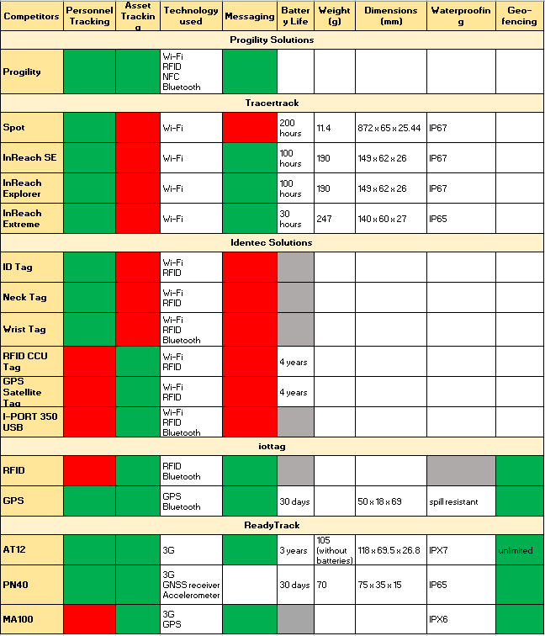

*- Function is available*

*- Function is not available*

*- Information unknown*

- *Function not applicable*

## The Competitors

### Progility Solutions

Progility Pty Ltd, trading as Progility Technologies, is a systems integrator and professional services provider supplying critical communications solutions. But more importantly, Progility has wing of business which focuses on real time location services. They are a company with over 20 years' experience in providing critical communications solutions to more than 5,000 Australian and international clients.

Progility offers a range of products which can be tailored to the client's’ environment and tracking needs. Some of the main features that the location-based tracking systems provide are:

* Time stamped location reporting services
* Escalation capability
* Exception incident reporting
* Asset tracking
* Digital voice communications (including voice recording)
* Emergency management

While the asset tracking systems use traditional GPS location information, in areas where GPS services is degraded, Progility provides Wi-Fi, Bluetooth, NFC and RFID based solutions. These can either compliment the GPS systems or be stand-alone systems where GPS service is not available. They provide expertise through the life cycle of the project from design through to implementation and post project fleet maintenance and support.

#### Progility Technologies [9]

* Provides Personnel and Asset Tracking through:
  + Wi-Fi systems
  + RFID
  + NFC
  + Bluetooth
* Location based services in GPS denied locations:
  + CA-TAP system-accuracy of approximately 1m
  + CA-TAP HD system-accuracy of approximately 55mm
* Underground mining and proximity detection
  + Distance between two points through hard rock
  + Custom alert system

### Tracertrak [11]

Tracertrak is a powerful exception management system providing global resource tracking and monitoring. Satellite technology is central to the entire Tracertrak design as it allows for true global resource visibility, driven by the need for corporate operational efficiency through systems that drive efficiency and productivity. It is a solution that is used extensively by government and enterprise organisations across Australia and New Zealand for tracking and monitoring assets, and personnel movement. It is system that is designed and optimised for a mining or oil rig environment, considering the number of customers they have in those sectors.

Some of benefits of using Tracertrak involve:

* Personnel Tracking
  + Address your duty of care for lone workers when they are outside of radio and mobile range.
  + Provide lone workers with a means of communication to signal for help in the event of an emergency.
  + Quick and simple procedure for lone workers to check-in from the field.
  + Maintain regular contact with lone workers while minimising interruptions to staff productivity.
* Asset Tracking
  + Maintain visibility of your remote assets whatever they are - lighting towers, drill rigs, generators, road plant – anything that moves.
  + Minimise time wasted searching for assets – ensure your maintenance and support teams are spending time utilising the assets – not hunting for them.
  + Be alerted of events such as "unauthorised movement", "door opened" or "engine on".
  + Effective group management means simple operation for large fleets of assets.

#### Tracertrak device capability

##### Spot

* Tracking
* Emergency Alerts
* Worker Check in

##### inReach SE

* Tracking
* Emergency Alerts
* Worker Check in
* Send and receive message
* Message Delivery Confirmation

##### inReach Explorer

* Tracking
* Emergency Alerts
* Worker Check in
* Send and receive message
* Message Delivery Confirmation
* Waypoint Saving

#### Iridium Extreme

* Tracking
* Emergency Alerts
* Worker Check in
* Send and receive message
* eDelivery Confirmation
* Voice Communications

### Identec Solutions [14]

Identec Solutions is a global provider of wireless solutions that deliver visibility to improve operational processes and security of personnel in harsh environments. They have developed robust wireless technology that are industry-specific for the world’s leading companies in the Oil & Gas, Ports & Terminals, Mining & Tunnelling and Automotive sectors. The industries and blue-chip customers we serve have the highest demands for performance, reliability and endurance.

Identec Solutions is the innovation leader setting the industry standards for reliability, ease of use and robustness of active RFID based wireless technologies.

#### 7.3.1 WATCHERPERSONNEL:

* Personnel registration system
* Automated mustering system
* Mobile mustering
* Access control system
* Certification logging
* Integration with DaWinci personnel logistics system
* Custom reporting
* Active and passive monitoring

IDENTEC SOLUTION **Mobile Mustering** increases security and improves efficiency during an emergency through:

* Automated headcount per mustering zone
* Manual mustering of personnel without a tag
* Flexible lifeboat allocation
* Simple relocation of mustering points
* Real-time identification of missing personnel
* Offline mode to mitigate network connectivity issues

### Iottag [26]

Iottag is an Australian owned and operated company that provides real-time location systems for improving workflow efficient and safety, with a focus on Bluetooth and GPS location in their tracking devices. The company is known to have assisted Tennis Australia for tracking items for staff along with various other industries, including support for the Manufacturing, Mining and Construction companies with their tools and equipment. They allow custom rules to be defined by the business for a solution that is best suited to them and allow an asset management system that is 1/5th the cost of alternative solutions, such as RFID.

#### Iottag device capability

##### Radio Frequency Identification (RFID) [28]

* Visibility of assets while on and off-site
* Separation alert
* Check-in and check-out
* Geo fence
* Call your tagged item
* 24-hour asset security
* Historical activity log
* Uses Bluetooth

##### Battery operated GPS tracking [29]

* 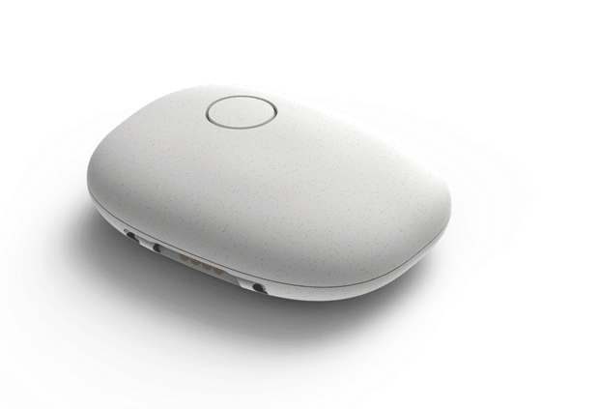Group share location
* Ultra-long rechargeable battery
* Emergency SOS
* Geo fencing

##### GPS Unit

* Vehicle tracking
* People tracking

##### Bluetooth FOB

* Security tracking
* Staff tracking
* Behavioural analytics

##### Bluetooth TAG

* Asset tracking
* People locating
* Fall detection

### ReadyTrack [27]

Ready Track Pty Ltd is an Australian company that produces one of the most comprehensive GPS tracking devices in the world, offering over 40 features and appealing to a large range of industries. The company not only provides solutions for personnel tracking but also assets, including vehicles. As a result, many aspects of the oil rig environment can benefit from this, including the features the company provides for plant equipment and lone workers. Some of the benefits for the Ready Track GPS Asset Tracking system include assets being in real time, history reports on location, alerts when some asset or personnel leaves their designated geofence, etc.

#### ReadyTrack device capability

##### AT12 Personnel/Asset GPS Tracker [30]

* Waterproof, IPX7 compliant
* Operates on 3G
* Shockproof (3m drop-tested)
* No wiring or external antennas
* Works on batteries that last up to 3 years
* Dual tracking mode to help track via GSM station in case of GPS tracking signal loss
* In case something moves to an area with no GSM signal, all location data will be stored on the inbuilt memory card and then uploaded onto the service once signal is achieved
* Can record data for up to 6 months (historical reports)
* Geo-fencing
* Configurable alerts

##### PN40 Personnel/Asset GPS Tracker [31]

* Designed for lone workers, vehicles, pets and

asset tracking applications

* Ideal for applications requiring rapid

emergency alert or instant geo-fencing

* Operates on 3G
* Waterproof, IP65 standard
* 30 days battery life
* Track on demand, by distance interval and by

time interval

* Shockproof to 1.5m
* State logger
* Geo-fencing

##### MA100 Motorcycle GPS Tracking Device [32]

* 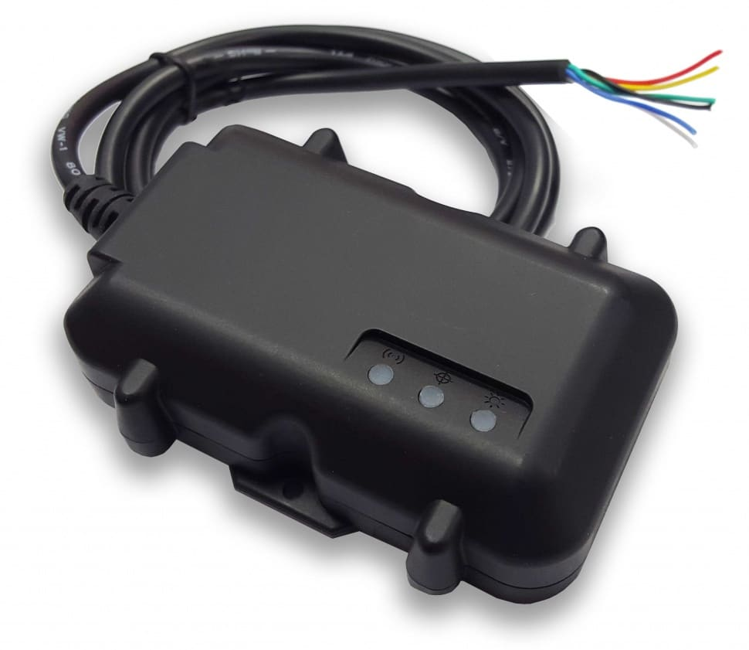Designed for applications that require low

current drain such as motorcycles, boats and machinery

* In-built GPS receiver
* Real-time location monitoring
* Periodical tracking by a backend server
* Operates on 3G
* Geo-fencing
* Messaging
* Dual tracking mode to help track via GSM station in case of GPS tracking signal loss
* In case something moves to an area with no GSM signal, all location data will be stored on the inbuilt memory card and then uploaded onto the service once signal is achieved
* Waterproof, IPX6
* Shockproof to 10m

# Scope for Innovation

By now it is clear that there already lots of solutions available on the market for personnel tracking. Each one has several configuration options and is specialized for a variety of environments. When attempting to deliver a solution to the market where the technology is not new, there are two options: implementing the existing solution into a new environment or adding functionality to the existing product.

It can be noted in the market analysis above that companies have not optimized their systems for use on an oil rig. The oil rig presents unique environmental challenges. Hence, one option for the team to pursue is to take a COTS product and harden it against exposure to salt water and sea spray.

Another key observation from the market analysis is that although most of the requirements desired by the client are covered by one system or another, there isn’t a single system that delivers exactly everything. This is true of the water immersion sensor, as this is usually a totally separate solution and not bundled with the tracking system.

Ultimately, our prototype will seek to address both opportunities. The budget for the project does not allow for us to fully waterproof an existing solution, but we can experiment on a limited scale. We can also combine a water immersion sensor with a basic tracking system to highlight the advantage of bundling them together for an oil rig environment.

# Conclusion

Preliminary market research reveals that the market for tracking systems is well saturated with companies such as Progility Technologies, ReadyTrack etc. specialising in rugged tracking tags designed for construction and mining operations [13]. Many potential competitors already offer devices which work in a general setting, accommodating lots of room for review and specialization to suit the environment of an oil-rig better. However, there appeared to be less saturation for a system specialized for use in an oil rig, so the focus was shifted from a general system to one optimized for that environment. Since the development of a completely new system may not be the most efficient way of moving- forward, two ways of potential action with the project were concluded:

1. Implementing existing solution into new environment
2. Adding functionality to existing product

Keeping this in mind, the recommendations that the team proposes to the client are:

* There are established COTS personnel and asset tracking systems that the client can use:
  + The most suited companies for an oil rig situation were found to be Progility Technologies and ReadyTrack, both of which address most of the major requirements that the client has put forward.
    - ReadyTrack is preferred by the team as there is more information available on the nature of the technology available.
* From all the information that was provided by the respective companies, fatigue monitoring and seawater detection were not found in any of the devices. While there are other COTS devices that perform this function, a fusion of the three devices, tracking, fatigue monitoring and seawater detection, will be needed to ensure that all the requirements of the client are met.

In summary, the team recommends implementing an existing solution into the oil rig situation, adding extra functionality to ensure that all the requirements are met.

# References

[1] R. FLIN, G. SLAVEN and K. STEWART, "Emergency Decision Making in the Offshore Oil and Gas Industry", *Human Factors: The Journal of the Human Factors and Ergonomics Society*, vol. 38, no. 2, pp. 262-277, 1996.

[2] J. Barab, "Worker Safety in our Nation's Energy Production Industries | Occupational Safety and Health Administration", *Osha.gov*, 2018. [Online]. Available: https://www.osha.gov/news/testimonies/06102012. [Accessed: 26- Mar- 2018].

[3] J. Skogdalen, I. Utne and J. Vinnem, "Developing safety indicators for preventing offshore oil and gas deepwater drilling blowouts", *Safety Science*, vol. 49, no. 8-9, pp. 1187-1199, 2011.

[4] A. Ene, "How Technology Is Changing The Oil And Gas Landscape - For The Better", *Smart-grid.energycioinsights.com*, 2018. [Online]. Available: https://smart-grid.energycioinsights.com/cxo-insights/how-technology-is-changing-the-oil-and-gas-landscape-for-the-better-nwid-51.html. [Accessed: 26- Mar- 2018].

[5] N. Ramzali, M. Lavasani and J. Ghodousi, "Safety barriers analysis of offshore drilling system by employing Fuzzy Event Tree Analysis", *Safety Science*, vol. 78, pp. 49-59, 2015.

[6] G. Mathisen and L. Bergh, "Action errors and rule violations at offshore oil rigs: The role of engagement, emotional exhaustion and health complaints", *Safety Science*, vol. 85, pp. 130-138, 2016.

[7] R. Gardner, "Overview and Characteristics of Some Occupational Exposures and Health Risks on Offshore Oil and Gas Installations", *The Annals of Occupational Hygiene*, vol. 47, no. 3, 2003.

[8] "Wearable Devices Used for Employee Location Tracking | Wearables List | Vandrico Inc", *Vandrico.com*, 2018. [Online]. Available: https://vandrico.com/wearables/device-categories/workplace-applications/employee-location-tracking. [Accessed: 26- Mar- 2018].

[9] "Home | progility.com.au", *Progility.com.au*, 2018. [Online]. Available: http://www.progility.com.au/. [Accessed: 26- Mar- 2018].

[10] J. Shoemaker, "When Does Tracking Workers Make Sense? - 2014-10-05 - Page 1 - RFID Journal", *Rfidjournal.com*, 2018. [Online]. Available: http://www.rfidjournal.com/articles/view?12274. [Accessed: 26- Mar- 2018].

[11] "LONE WORKER SAFETY AND SATELLITE COMMUNICATIONS", *Tracertrak.com.au*, 2018. [Online]. Available: http://www.tracertrak.com.au/wp-content/uploads/sites/2/2016/07/Tracertrak-AU-Lone-Worker-07072016.pdf. [Accessed: 26- Mar- 2018].

[12] "Products | Emerald Marine Products", *Emeraldmarineproducts.com*, 2018. [Online]. Available: http://emeraldmarineproducts.com/products/. [Accessed: 26- Mar- 2018].

[13] E. Web, "Activ Tags | Wavetrend", *Wavetrend.net*, 2018. [Online]. Available: http://www.wavetrend.net/activ-tags.php. [Accessed: 27- Mar- 2018].

[14] "Oil and Gas Industry Wireless RFID and GPS Solutions - Identec Solutions", Identec Solutions, 2018. [Online]. Available: https://www.identecsolutions.com/oil-gas-industry-solutions/. [Accessed: 28- April- 2018].

[15] "What Is a Wireless Sensor Network? - National Instruments", Ni.com, 2016. [Online]. Available: http://www.ni.com/white-paper/7142/en/. [Accessed: 28- April- 2018].

[16] M. Rahman, D. Habibi and I. Ahmad, "Source Localisation in Wireless Sensor Networks Based on Optimised Maximum Likelihood", 2008 Australasian Telecommunication Networks and Applications Conference, 2008.

[17] M. Farag, M. Abo-Zahhad, M. Doss and J. Fayez, "Different Aspects of Localization Problem for Wireless Sensor Networks: A Review", International Journal of Computer Networks and Communications Security, vol. 4, no. 5, 2016

[18] M.‎ Vojdani,‎ M.‎ Dehghan,‎ “Localization‎ in‎ Anchor‎ less‎ Wireless‎ Sensor‎ Network,”‎ in‎ International Conference on Computer Engineering and Applications, Singapore, 2011, vol.2, pp. 365-368

[19] S. A. Mitilineos, D. M. Kyriazanos, O. E. Segou, J. N. Goufas and S. C. A. Thomopoulos “Indoor‎ Localization‎ with‎ Wireless‎ Sensor‎ Networks,”‎Electromagnetic‎Research,‎vol.109,‎ pp.441-474, 2010.

[20]K. Mondal, P. S. Mandal, and B. P. Sinha “Localization‎ in‎ Presence‎ of‎ Multipath‎ Effect‎ in‎ Wireless‎ Sensor‎ Networks,”‎ in‎ Proc.‎ WWIC’12,‎2012,‎paper‎10.1007,‎pp.‎138-149.

[21]S. Dixit, "Wireless Sensor Networks: Issues & Challenges", International Journal of Computer Science and Mobile Computing, vol. 3, no. 6, pp. 681 – 685, 2014.

[22]T. Watteyne, S. Lanzisera, A. Mehta and K. Pister, "Mitigating Multipath Fading through Channel Hopping in Wireless Sensor Networks", 2010 IEEE International Conference on Communications, 2010.

[23]G. Balakrishnan, M. Yang, Y. Jiang and Y. Kim, "Performance Analysis of Error Control Codes for Wireless Sensor Networks", Fourth International Conference on Information Technology (ITNG'07), 2007

[24]K. Kasinathan and M. Younis, "Distributed approach for mitigating coverage loss in heterogeneous wireless sensor networks", 2011 IEEE GLOBECOM Workshops (GC Wkshps), 2011.

[25] P. Vaishnav and N. Tada, "A new approach to routing mechanism in Wireless Sensor Network environment", 2013 Nirma University International Conference on Engineering (NUiCONE), 2013.

[26]"About Us - Iottag™", Iottag™, 2018. [Online]. Available: http://iottag.com.au/about-us/. [Accessed: 1- May- 2018].

[27]"ReadyTrack", Readytrack.com.au, 2018. [Online]. Available: https://www.readytrack.com.au/about/. [Accessed: 1- May- 2018].

[28] Iottag™. (2018). Bluetooth tracking | Equipment Tracking | RF Tracking Asset Tag - Iottag™. [online] Available at: http://iottag.com.au/bluetooth-tracking/ [Accessed 26 April 2018].

[29] Iottag™. (2018). GPS Tracking | Equipment Tracking - Iottag™. [online] Available at: http://iottag.com.au/gps-tracking/ [Accessed 1 May 2018].

[30] Readytrack.com.au. (2018). [online] Available at: https://www.readytrack.com.au/at12/ [Accessed 1 May 2018].

[31] Readytrack.com.au. (2018). [online] Available at: https://www.readytrack.com.au/pn40/ [Accessed 1 May 2018].

[32] Readytrack.com.au. (2018). [online] Available at: https://www.readytrack.com.au/ma100-motorcycle-gps-tracking-device/ [Accessed 1 May 2018].

# Appendix

## House of Quality

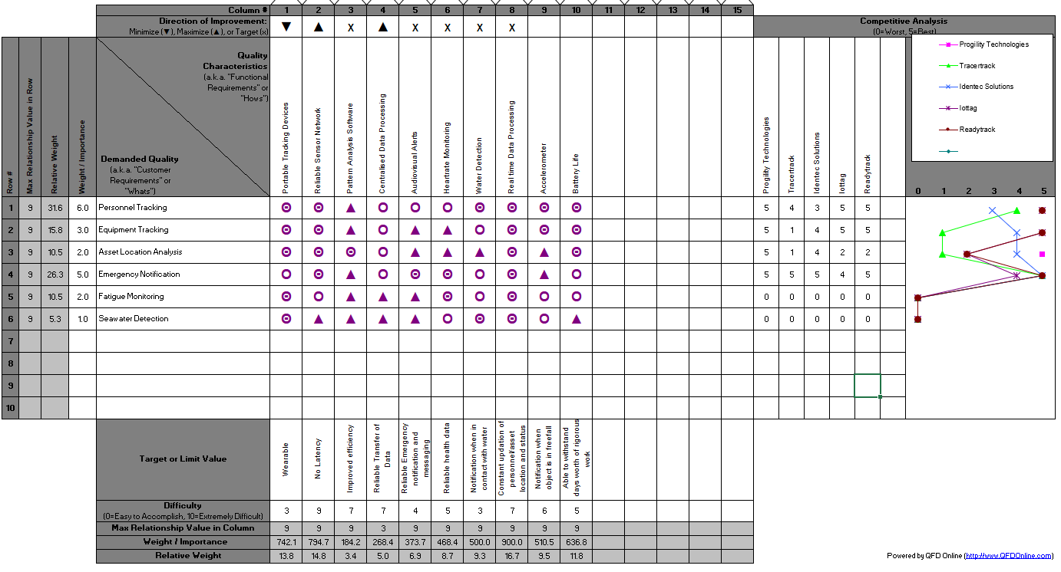

## Pairwise Analysis

|  |  |  |  |  |  |  |  |  |
| --- | --- | --- | --- | --- | --- | --- | --- | --- |
|  | Personnel Tracking | Equipment Tracking | Asset Location Analysis | Emergency Notification | Fatigue Monitoring | Seawater Detection | Sum | Rank |
| Personnel Tracking |  | 1 | 1 | 1 | 1 | 1 | 5 | 1 |
| Equipment Tracking | 0 |  | 1 | 0 | 1 | 1 | 3 | 3 |
| Asset Location Analysis | 0 | 0 |  | 0 | 0 | 1 | 1 | 5 |
| Emergency Notification | 0 | 1 | 1 |  | 1 | 1 | 4 | 2 |
| Fatigue Monitoring | 0 | 0 | 1 | 0 |  | 1 | 2 | 4 |
| Seawater Detection | 0 | 0 | 0 | 0 | 0 |  | 0 | 6 |